**Keerthi Sweets Project Report**

1. **Project Introduction**

Introduction to the “Keerthi Sweets” project. Objectives and goals of the project.

* 1. **Project overview** Established in the year 2003, keerthi sweets in Madippakam, Chennai is a top player in the category Bakeries in the Chennai.
  2. **Purpose** Hostling a small party at home and want to serve delicious sweets and scrumptious savoury products to your guests? It’s a special occasion and looking forward to surprising them with their favourite desserts? A bakery can address all these needs! Bakeries are stores that offer sweet as well as savoury products to visitors. Its fulfils all your cravings under one roof.

1. **Problem Definition and Design Thinking**

**2.1 Empathy Map** 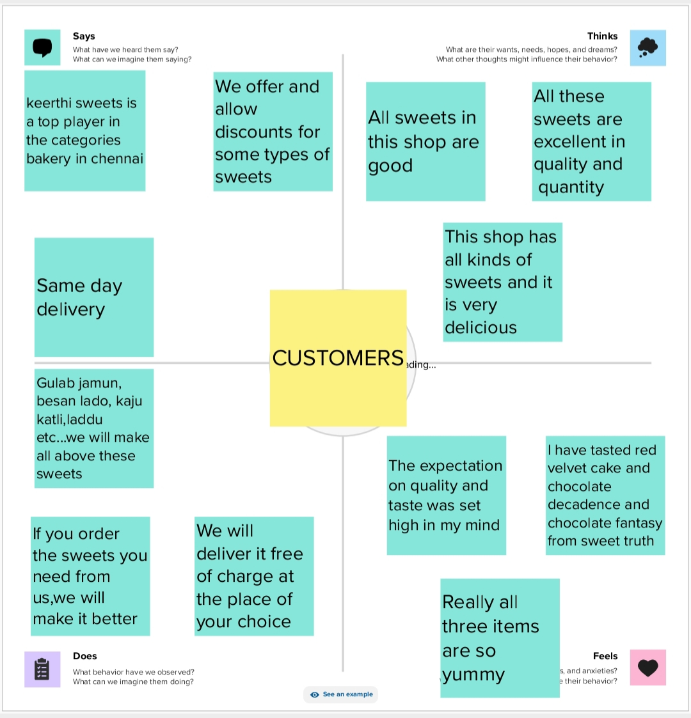

**2.2 Ideation and Brainstorm**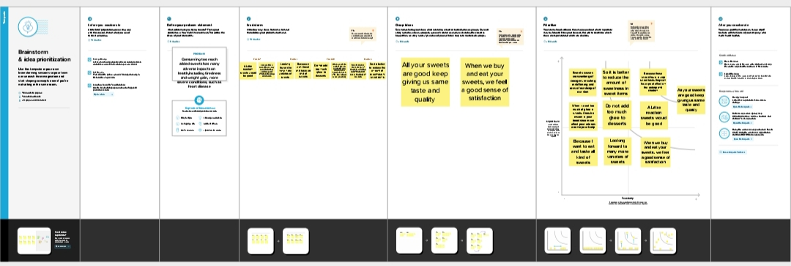

1. **Result**

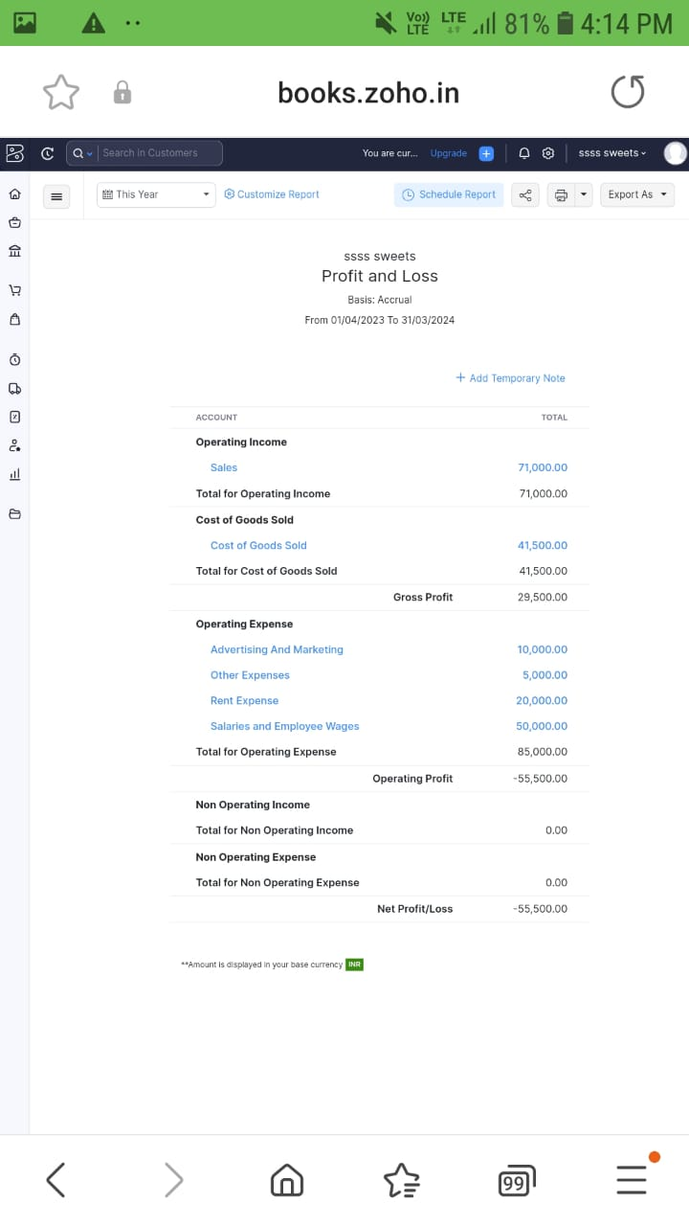

1. **Advantages and Disadvantages** Eating sweets can boost your mood and provide a quick energy boost. Eating sweets can make special occasions or holidays more enjoyable.

Eating too many sweets can cause weight gain.

1. **Applications Keerthi Sweets:** An” Keerthi Sweets” project could satisfy your thirst for treat with sweets like rasagula, gulab jamun and natural sweets.
2. **Conclusion** This program had been successfully executed.
3. **Future scope** Zoho development is going to focus on cloud service.
4. **Appendix** A. Source code

<https://github.com/MYSS2003/keerthi-Sweets_18421>